Employee Engagement and Burnout Risk Assessment Using Composite Index Modeling and Interactive Workforce Analytics

Abstract— Employee engagement and occupational burnout significantly influence workforce productivity and organizational sustainability. This research presents a structured analytical framework for evaluating employee engagement through a composite index approach and identifying burnout risk using rule-based classification logic. The study integrates data preprocessing, feature engineering, quantitative modeling, and interactive visualization to provide interpretable workforce intelligence. Experimental analysis demonstrates that overtime exposure and reduced work-life balance are strongly associated with elevated burnout risk. The proposed framework offers a scalable and transparent decision-support model suitable for modern HR analytics environments.

Keywords— Employee Engagement, Burnout Risk, HR Analytics, Composite Index, Workforce Intelligence, Data Visualization.

Introduction

Organizations increasingly rely on workforce analytics to monitor employee satisfaction, productivity, and
well-being. Employee engagement reflects emotional commitment toward organizational objectives, whereas burnout represents chronic workplace stress leading to reduced performance. Traditional HR dashboards provide descriptive summaries but lack structured analytical modeling. This study introduces a composite engagement index and interpretable burnout classification model supported by interactive visualization.Organizations increasingly rely on workforce analytics to monitor employee satisfaction, productivity, and well-being. Employee engagement reflects emotional commitment toward organizational objectives, whereas burnout represents chronic workplace stress leading to reduced performance.
Traditional HR dashboards provide descriptive summaries but lack structured analytical modeling. This study introduces a composite engagement index and interpretable burnout classification model supported by interactive visualization.Organizations increasingly rely on workforce analytics to monitor employee satisfaction, productivity, and well-being. Employee engagement
reflects emotional commitment toward organizational objectives, whereas burnout represents chronic workplace stress leading to reduced performance.
Traditional HR dashboards provide descriptive summaries but lack structured analytical modeling. This study introduces a composite engagement index and interpretable burnout classification model supported by interactive visualization.

Related Work

Prior studies highlight survey-based engagement scoring and psychological burnout measurement frameworks. However, many implementations rely solely on static reporting or complex black-box models. The need for interpretable, scalable, and practical analytical frameworks remains critical in HR analytics.Prior studies highlight survey-based engagement scoring and psychological burnout measurement frameworks.
However, many implementations rely solely on static reporting or complex black-box models. The need for interpretable, scalable, and practical analytical frameworks remains critical in HR analytics.Prior studies highlight survey-based engagement scoring and psychological burnout measurement frameworks.
However, many implementations rely solely on static reporting or complex black-box models. The need for interpretable, scalable, and practical analytical frameworks remains critical in HR analytics.

Methodology

The methodology consists of data cleaning, normalization of satisfaction metrics, composite index computation, burnout classification, and visualization. The Engagement Index (EI) is calculated as the arithmetic mean of standardized satisfaction attributes including job satisfaction, environment satisfaction, and involvement level. Burnout Risk (BR) is categorized using rule-based thresholds derived from overtime status and work-life balance indicators.The methodology consists of data cleaning, normalization of satisfaction metrics, composite index computation, burnout classification, and visualization. The Engagement Index (EI) is calculated as the arithmetic mean of standardized satisfaction attributes including job satisfaction, environment satisfaction, and involvement level.
Burnout Risk (BR) is categorized using rule-based thresholds derived from overtime status and work-life balance indicators.The methodology consists of data cleaning, normalization of satisfaction metrics, composite index computation, burnout classification, and visualization. The Engagement Index (EI) is calculated as the arithmetic mean of standardized satisfaction attributes including job satisfaction, environment satisfaction, and involvement level.

Burnout Risk (BR) is categorized using rule-based thresholds derived from overtime status and work-life balance indicators.

Mathematical Model

The Engagement Index is defined as: EI = (JS + ES + JI
+ WLB) / 4, where JS denotes Job Satisfaction, ES denotes Environment Satisfaction, JI denotes Job Involvement, and WLB denotes Work-Life Balance. Burnout classification rules assign High Risk to employees with overtime exposure and low work-life balance scores.The Engagement Index is defined as: EI
= (JS + ES + JI + WLB) / 4, where JS denotes Job Satisfaction, ES denotes Environment Satisfaction, JI denotes Job Involvement, and WLB denotes Work-Life Balance. Burnout classification rules assign High Risk to employees with overtime exposure and low work-life balance scores.The Engagement Index is defined as: EI
= (JS + ES + JI + WLB) / 4, where JS denotes Job Satisfaction, ES denotes Environment Satisfaction, JI denotes Job Involvement, and WLB denotes Work-Life Balance. Burnout classification rules assign High Risk to employees with overtime exposure and low work-life balance scores.

Results and Analytical Insights

Analysis indicates that departments with higher overtime participation exhibit increased burnout distribution.
Employees demonstrating moderate engagement scores display improved stability compared to low engagement groups. The visualization framework enables dynamic segmentation by department and overtime status.Analysis indicates that departments with higher overtime participation exhibit increased burnout distribution. Employees demonstrating moderate engagement scores display improved stability compared to low engagement groups. The visualization framework enables dynamic segmentation by department and overtime status.Analysis indicates that departments with higher overtime participation exhibit increased burnout distribution. Employees demonstrating moderate engagement scores display improved stability compared to low engagement groups. The visualization framework enables dynamic segmentation by department and overtime status.

Discussion

The findings emphasize the importance of balancing workload with engagement enhancement strategies. The composite index approach ensures interpretability while supporting managerial decision-making.The
findings emphasize the importance of balancing workload with engagement enhancement strategies. The composite index approach ensures interpretability while supporting managerial decision-making.The findings emphasize the importance of balancing workload with engagement enhancement strategies. The composite index approach ensures interpretability while supporting managerial decision-making.

Limitations

The study uses structured survey-style attributes and rule-based classification rather than predictive machine learning models. Future implementations may incorporate time-series analysis and supervised learning approaches.The study uses structured survey-style attributes and rule-based classification rather than predictive machine learning models. Future implementations may incorporate time-series analysis and supervised learning approaches.The study uses structured survey-style attributes and rule-based classification rather than predictive machine learning models. Future implementations may incorporate
time-series analysis and supervised learning approaches.

Conclusion and Future Scope

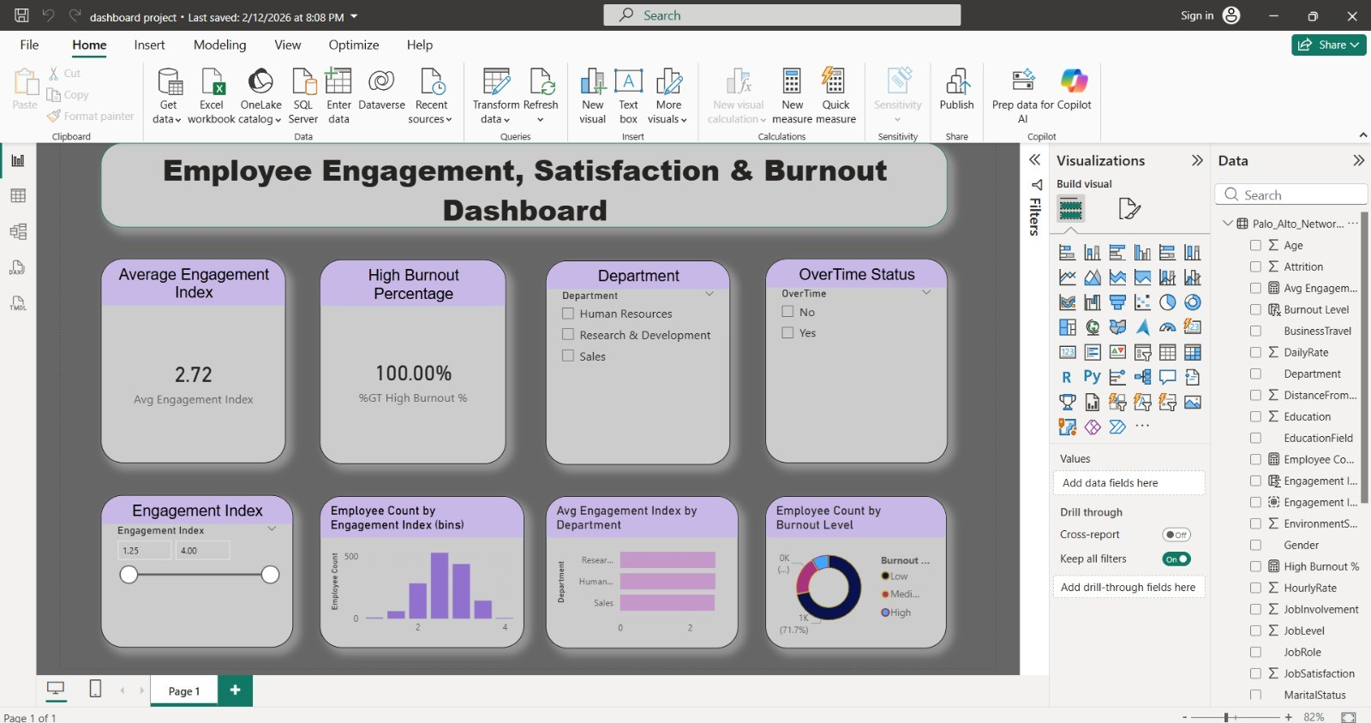
The proposed framework offers an interpretable and scalable workforce analytics solution. Future research may integrate predictive modeling, sentiment analysis, and enterprise HR system integration.The proposed framework offers an interpretable and scalable workforce analytics solution. Future research may integrate predictive modeling, sentiment analysis, and enterprise HR system integration.The proposed framework offers an interpretable and scalable workforce analytics solution. Future research may integrate predictive modeling, sentiment analysis, and enterprise HR system integration.

Fig. 1. Employee Engagement, Satisfaction and Burnout Interactive Dashboard Overview.

References

- W. H. Macey and B. Schneider, 'The meaning of employee engagement,' Industrial and Organizational Psychology, 2008.

- C. Maslach and M. P. Leiter, 'Understanding the burnout experience,' World Psychiatry, 2016.

- A. Saks, 'Antecedents and consequences of employee engagement,' Journal of Managerial Psychology, 2006.

- T. H. Davenport and J. Harris, Competing on Analytics, Harvard Business School Press, 2007.

- J. W. Creswell, Research Design, 4th ed., Sage Publications, 2014.

- R. Kaplan and D. Norton, Strategy-Focused Organization, Harvard Business School Press, 2001.

- G. Shmueli, Data Mining for Business Analytics, Wiley, 2016.

- IEEE Editorial Style Manual, IEEE Standards Association, 2023.

